***“PHONE DIRECTORY”***

A MINI- PROJECT REPORT ON

Submitted in partial fulfilment of the requirements

For the degree of

Bachelor of Engineering

In

Information Technology

by

**ASHWATI RAO 18IT2018**

**SAGAR NIRMAL 18IT1095**

**SAHIL SATAV 18IT1007**

Supervisor

**Nilima Dongre**



Department of Information Technology

Dr. D. Y. Patil Group’s

**Ramrao Adik Institute of Technology**

Dr. D. Y. Patil Vidyanagar, Sector 7, Nerul, Navi Mumbai 400706.

(Affiliated to University of Mumbai)

( 2020)

# rait logo

Ramrao Adik Institute of Technology

(Affiliated to the University of Mumbai)

Dr. D. Y. Patil Vidyanagar,Sector 7, Nerul, Navi Mumbai 400706.

CERTIFICATE

This is to certify that,Mini Project entitled

“ PHONE DIRECTORY ”

is a bonafide work done by

ASHWATI RAO(18IT2018)

SAGAR NIRMAL(18IT1095)

SAHIL SATAV(18IT1007)

and is submitted in the partial fulfilment of the requirement for the

degree of

Bachelor of Engineering

in

Information Technology

to the

University of Mumbai

Supervisor

Prof.Nilima M.Dongre

Project Guide Head of the department

Nilima Dongre Dr. Ashish Jadhav

Certificate of Approval by Examiners

This Mini Project report entitled “ Phone Directory ” is a bonafide work done by Ms.Ashwati Rao, Mr.Sagar Nirmal and Mr.Sahil Satav under the supervision of Prof.Nilima Dongre approved for the award of Bachelor Degree in Information Technology, University of Mumbai.

Examiners :

1. . . . . . . . . . . . . . . . . . . . . . . . . . . . . . .

2. . . . . . . . . . . . . . . . . . . . . . . . . . . . . . .

Supervisors :

1. . . . . . . . . . . . . . . . . . . . . . . . . . . . . . .

2. . . . . . . . . . . . . . . . . . . . . . . . . . . . . . .

Principal :

. . . . . . . . . . . . . . . . . . . . . . . . . . . . . .

Date :

Place :

# **DECLARATION**

We declare that this written submission represents our ideas in our own words and where others' ideas or words have been included, we have adequately cited and referenced the original sources. We also declare that we have adhered to all principles of academic honesty and integrity and have not misrepresented or fabricated or falsified any idea/data/fact/source in our submission. We understand that any violation of the above will be cause for disciplinary action by the Institute and can also evoke penal action from the sources which have thus not been properly cited or from whom proper permission has not been taken when needed.

**Name and Roll No. of Students Signature**

1. Ms. Ashwati Rao (18IT2018)

2. Mr. Sagar Nirmal (18IT1095)

3. Mr. Sahil Satav (18IT1007)

Date:1/04/2020

Place: Navi Mumbai

# ACKNOWLEDGEMENT

The project “PHONE DIRECTORY” is creative work of many minds. A proper synchronization between individual is must for any project to be completed successfully. One cannot imagine the power of the force that guides us all and neither can we succeed without acknowledging it.

We take this opportunity to express my profound gratitude and deep regards to our Guide **Nilima Dongre**, Department of the Information Technology Engineering for her or her exemplary guidance, monitoring and constant encouragement throughout the completion of this mini project.

We would like to express our gratitude to **Dr. Ashish Jadhav,** Head of the department, Information Technology Engineering for encouraging and inspiring us to carry out the project in the department lab. We take this privilege to express my sincere thanksare thankful to **Dr. Mukesh D. Patil, Principal RAIT,** for his constant support and motivation.

We also would like to thank all the staff members Department of the Information Technology Engineering for providing us with the required facilities and support towards the completion of the project.

Last but not the least we are thankful to our parents and friends for their constant Inspiration, encouragement and well wishes by which we have made a challenging project.

STUDENT-NAME (ROLLNO) Signature

ASHWATI RAO(18IT2018)

SAGAR NIRMAL(18IT1095)

SAHIL SATAV(18IT1007)

# **PREFACE**

We take great opportunity to present this Mini Project report on “**PHONE DIRECTORY”** and put before readers some useful information regarding our project.

We have made sincere attempts and taken every care to present this matter in precise and compact form, the language being as simple as possible. We are sure that the information contained in this volume certainly prove useful for better insight in the scope and dimension of this project in it true perspective.

The task of the completion of the project though being difficult was made quite simple, interesting and successful due to deep involvement and complete dedication of our group members.

**TABLE OF CONTENTS**

**Declaration …………….…….………………………………………… I**

**Acknowledgement ……...……………………………………………… II**

**Preface …………….…………………………………………………… III**

**Table of Contents ……………………………………………………… IV**

**Table of figures ...…………………………………………………….… V**

**Abstract…….....…………………………………………………..…….. VI**

**TABLE OF CONTENTS**

**Sr. No. Topic Page No.**

1. **INTRODUCTION………………………………………………………………..8**
   1. **INTRODUCTION TO SCRIPTING LANGUAGES………………………10**
   2. **WHY PARTICULAR SCRIPTING LANGUAGE………………………...11**
   3. **PROBLEM STATEMENT………………………………………………….12**
   4. **OBJECTIVES………………………………………………………………..13**
2. **LITERATURE SURVEY……………………………………………………….14**
   1. **MOTIVATION………………………………………………………………15**
3. **PROPOSED SYSTEM…………………………………………………………..16**
   1. **INTRODUCTION OF PROPOSED SYSTEM AND**

**ARCHITECTURE …………………………………………………………...16**

* 1. **HARDWARE AND SOFTWARE REQUIREMENTS……………………17**

1. **IMPLEMENTATION……………………………………………………………21**
   1. **SYSTEM BLOCK DIAGRAM……………….……………………………...21**
   2. **MODULE DESCRIPTION………………………………………………...22**
   3. **CODE………………………………………………………………………….26**
2. **RESULT…………………………………………………………………………...36**
   * 1. **OUTPUT SNAPSHOTS**
     2. **TESTING AND VALIDATION**
3. **CONCLUSION AND FUTURE SCOPE………………………………………..37**
   1. **CONCLUSION……………………………………………………………….37**
   2. **FUTURE SCOPE…………………………………………………………….37**
   3. **BENEFITS TO SOCIETY…………………………………………………..38**
4. **REFERENCES……………………………………………………………………47**

INTRODUCTION

# SCRIPTING LANGUAGES:

Scripting is the action of writing scripts using a scripting language, distinguishing neatly between programs, which are written in conventional programming language such as C, C++, java, and scripts, which are written using a different kind of language.

We could reasonably argue that the use of scripting languages is just another kind of programming. Scripting languages are used for is qualitatively different from conventional programming languages like C++ and Ada address the problem of developing large applications from the ground up, employing a team of professional programmers, starting from well-defined specifications, and meeting specified performance constraints.

Scripting languages, on other hand, address different problems:

♣ Building applications from ‘off the shelf’ components

♣ Controlling applications that have a programmable interface

♣ Writing programs where speed of development is more important than run-time efficiency

The most important difference is that scripting languages incorporate features that enhance the productivity of the user in one way or another, making them accessible to people who would not normally describe themselves as programmers, their primary employment being in some other capacity. Scripting languages make programmers of us all, to some extent.

 Scripting languages can be divided into two categories:

* Server Side Scripting Languages
* Client Side Scripting Languages
* **Server-side** scripting languages create the scripts that run on the server and hence minimize the workload of a browser. The functionality of your website is written in those scripting languages. The most commonly used server-side scripting languages are **Perl**, **Ruby**, **Python**, **PHP**, etc.
* **Client-side** scripting languages create the scripts that run on the client side (i.e. your browser). These are sent from the server by server-side scripts. Some good examples are **JavaScript**, **jQuery**, **CSS** etc.

# **CHARACTERISTICS OF SCRIPTING LANGUAGES:**

These are some properties of scripting languages which differentiate SL from programming languages.

* **Integrated compile and run**: SL’s are usually characterized as interpreted languages, but this is just an oversimplification. They operate on an immediate execution, without need to issue separate command to compile the program and then to run the resulting object file, and without the need to link extensive libraries into the object code. This is done automatically. A few SL’S are indeed implemented as strict interpreters.
* **Low overheads and ease of use**: 1.variables can be declared by use 2.the number of different data types is usually limited 3.everything is string by context it will be converted as number(vice versa) 4.number of data strucures is limited(arrays).
* **Enhanced functionality:** SL’s usually have enhanced functionality in some areas. For example ,most languages provide string manipulation based on the use of regular expressions, while other languages provide easy access to low-level operating system facilities, or to the API, or object exported by an application.
* **Efficiency is not an issue**: ease of use is achieved at the expense of effeciency, because efficiency is not an issue in the applications for which SL’S are designed.
* A scripting language is usually interpreted from source code or bytecode. By contrast, the software environment the scripts are written for is typically written in a compiled language and distributed in machine code form.
* Scripting languages may be designed for use by end users of a program – end-user development – or may be only for internal use by developers, so they can write portions of the program in the scripting language.
* Scripting languages typically use abstraction, a form of information hiding, to spare users the details of internal variable types, data storage, and memory management.
* Scripts are often created or modified by the person executing them, but they are also often distributed, such as when large portions of games are written in a scripting language.
* The characteristics of ease of use, particularly the lack of an explicit compile-link-load sequence, are sometimes taken as the sole definition of a scripting language.

# **ADVANTAGES OF SCRIPTING LANGUAGES:**

* **Easy learning:** The user can learn to code in scripting languages quickly, not much knowledge of web technology is required.
* **Fast editing:** It is highly efficient with the limited number of data structures and variables to use.
* **Interactivity:** It helps in adding visualization interfaces and combinations in web pages. Modern web pages demand the use of scripting languages. To create enhanced web pages, fascinated visual description which includes background and foreground colors and so on.
* **Functionality:** There are different libraries which are part of different scripting languages. They help in creating new applications in web browsers and are different from normal programming languages.

# DISADVANTAGES OF SCRIPTING LANGUAGE

* Can be slower to run since they are interpreted and not compiled into machine code.
* Can be harder to debug since no development environment is available by default.
* Since they are text based it is easy for other people to modify and thus break it.

# **APPLICATION OF SCRIPTING LANGUAGES:**

* Scripting languages are used in web applications. It is used in server side as well as client side. Server side scripting languages are: JavaScript, PHP, Perl etc. and client side scripting languages are: JavaScript, AJAX, jQuery etc.
* Scripting languages are used in system administration. For example: Shell, Perl, Python scripts etc.
* It is used in Games application and Multimedia.
* It is used to create plugins and extensions for existing applications.

# EXAMPLES OF SCRIPTING LANGUAGES:

* **Bash:** It is a scripting language to work in the Linux interface. It is a lot easier to use bash to create scripts than other programming languages. It describes the tools to use and code in the command line and create useful reusable scripts and conserve documentation for other people to work with.
* **Node js:** It is a framework to write network applications using JavaScript. Corporate users of Node.js include IBM, LinkedIn, Microsoft, Netflix, PayPal, Yahoo for real-time web applications.
* **Ruby:** There are a lot of reasons to learn Ruby programming language. Ruby’s flexibility has allowed developers to create innovative software. It is a scripting language which is great for web development.
* **Python:** It is easy, free and open source. It supports procedure-oriented programming and object-oriented programming. Python is an interpreted language with dynamic semantics and huge lines of code are scripted and is currently the most hyped language among developers.
* **Perl:** A scripting language with innovative features to make it different and popular. Found on all windows and Linux servers. It helps in text manipulation tasks. High traffic websites that use Perl extensively include priceline.com, IMDB.

# **Bash Shell Scripting**

What is Bash?

[Bash](https://en.wikipedia.org/wiki/Bash_(Unix_shell))(AKA **B**ourne **A**gain **Sh**ell) is a "Unix shell": a command line interface for interacting with the operating system. It is widely available, being the default shell on many GNU/Linux distributions and on Mac OSX, with ports existing for many other systems. It was created in the late 1980s by a programmer named Brian Fox, working for the Free Software Foundation. It was intended as a free software alternative to the Bourne shell (in fact, its name is an acronym for Bourne Again SHell), and it incorporates all features of that shell, as well as new features such as integer arithmetic and job control.

Bash gives you a set of commands that put together can be used to create little programs, that by convention we call scripts.Note the difference. We don’t say Bash programming but Bash scripting, and we don’t call Bash scripts “Bash programs”. This is because you can generally reach a certain amount of complexity before feeling that your scripts gets out of hand.But Bash scripts are great because you don’t need anything else than Bash to run them. No compiler, no interpreter, just your shell.

What is shell scripting?

In addition to the interactive mode, where the user types one command at a time, with immediate execution and feedback, Bash (like many other shells) also has the ability to run an entire script of commands, known as a "Bash shell script" (or "Bash script" or "shell script" or just "script"). A script might contain just a very simple list of commands — or even just a single command — or it might contain functions, loops, conditional constructs, and all the other hallmarks of imperative programming. In effect, a Bash shell script is a computer program written in the Bash programming language.

Shell scripts can be called from the interactive command-line described above; or, they can be called from other parts of the system. One script might be set to run when the system boots up; another might be set to run every weekday at 2:30 AM; another might run whenever a user logs into the system.

Shell scripts are commonly used for many system administration tasks, such as performing disk backups, evaluating system logs, and so on. They are also commonly used as installation scripts for complex programs. They are particularly suited to all of these because they allow complexity without requiring it: if a script just needs to run two external programs, then it can be a two-line script, and if it needs all the power and decision-making ability of a Turing-complete imperative programming language, then it can have that as well.

# PROBLEM STATEMENT:

Phone book is a project that provides us technical help to get a simple scripting language-based solution to store our contacts. We can use it to replace our hard phonebook or even use it as an office-wide phone directory. This will help user to easily search and manage contact using this system. Phonebook is the one which contains details of an individual along with their phone numbers. Apart from the telephone number o individual it also contains important numbers of individual. The names are present in the order they are saved. This system is developed using a general need required by the user while using the phone directory book. In order to keep the phonebook updated the admin will have the authority to perform various operations such as add customer records and listing details of the available records, delete records etc. To provide search results within short interval of time optimized search algorithm has been used that will be able to give results within seconds. To make all operations as easier as possible, user-friendly approach has been taken into account by which user have to only give their answer during the final confirmation to make their operation successful. The background processing system will take care of all processing task and maintain data integrity in order to reduce the redundancy of data. For searching operation, user will be able to get any particular record using their contact or phone number the only condition is that, customer records should be available within the file system. If no such record exists proper error message will be displayed as per input provided to the system.

# OBJECTIVE:

The aim is to create a phone directory using bash shell scripting. The phone directory should be able to

1. Save a person’s phone number
2. Save a person’s name
3. Delete saved contact information
4. Search a previously saved contact
5. View the phone directory.
6. Quit from the program

# LITERATURE SURVEY

* Phone book is a project that provides us technical help to get a simple scripting language-based solution to store our contacts.
* This will help user to easily search and manage contacts using this system.
* For searching operation, users will be able to get any particular record using their contact or phone numbers but the only condition is that, customers record must be available within the file system.

**PROPOSED SYSTEM**

**INTRODUCTION-**

The main objective of this Phone Directory System is to store the contact details of the desired persons.

Phone Directory is a project which helps us to get a simple solution to store our contacts. We can use it to replace our hard phonebook or even use it as an office-wide phone directory. This will help user to easily search and manage contacts using this system.

This system is developed using the general need required by the user to store contact numbers. In order to keep the phone directory updated, the user will have the authority to add and delete as well as modify the existing records within the phone book directory.

**Telephone Directory System Modules**-

* **Insert module**: In this module, all the details regarding contacts are inserted.
* **Delete module**: In this module, the records with a specific id is deleted.
* **View module**: This module allows the user to view all the existing records.
* **Search module**: This module allows to search for the contact details by just entering its name.

**HARDWARE AND SOFTWARE REQUIREMENTS-**

Software used to make phone directory is Ubuntu 18.04 which is installed on Virtual Box.

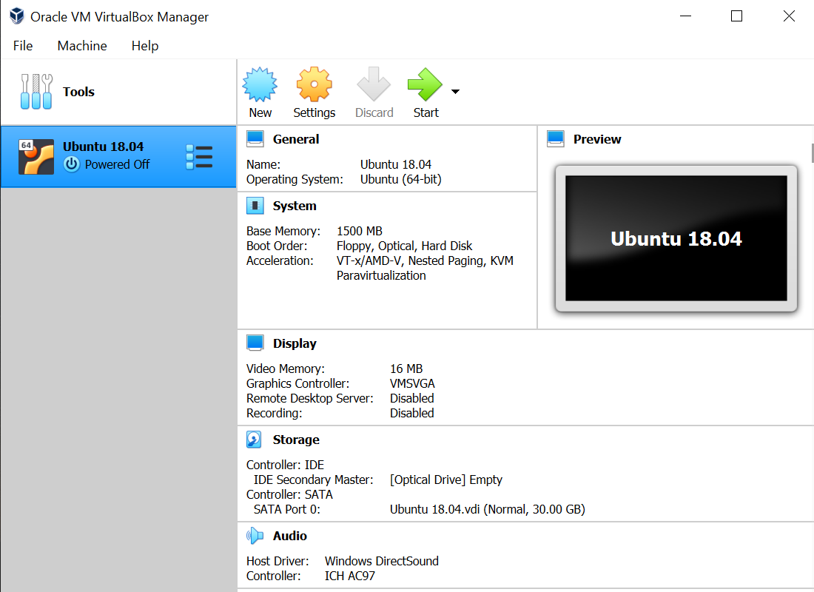

**SYSTEM BLOCK DIAGRAM-**

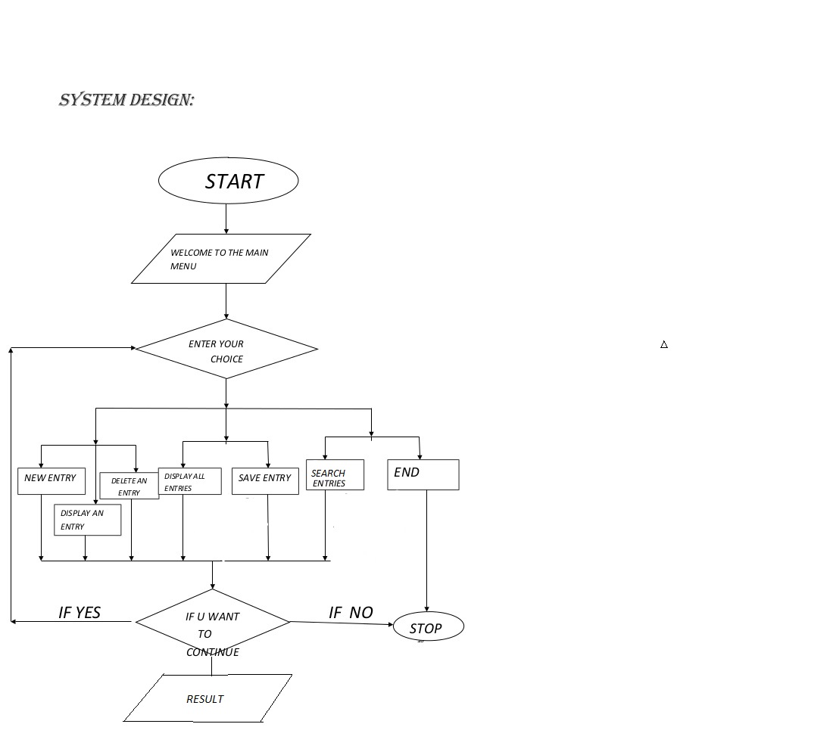

**CODE-**

#!/bin/bash

while :

do

clear

echo "Welcome to Phone Directory"

echo "1.Add a contact"

echo "2.Search a contact"

echo "3.Delete a contact"

echo "4.View Phone Directory"

echo "5.Quit"

read -p "Enter your choice " usr_cmd

clear

case $usr_cmd in

1)echo "Add New Contact"

read -p "Enter Name- " name

echo "Got That!"

read -p "Enter Number- " number

clear

echo "New Contact Info:"

echo "-> Name: $name. -> Number: $number"

echo "$name : $number" >> phonedir.log

echo "Saved Successfully"

;;

2)echo "Search Contact"

read -p "Enter the name- " search_query

clear

echo "Search Results:"

grep -i $search_query phonedir.log

;;

3)echo "Delete Contact"

read -p "Enter name to be deleted(case-sensitive):" delete_string

sed -i -e "/$delete_string/d" phonedir.log

echo "Deleted Successfully"

;;

4)echo "PHONE DIRECTORY"

echo " "

cat phonedir.log

;;

5)break;;

*)echo"INVALID OPTION";;

esac;

read -p "Press 5 to quit, Anything else to return to main menu" confirm_exit

if [ $confirm_exit -eq 5 ]

then break

fi

done

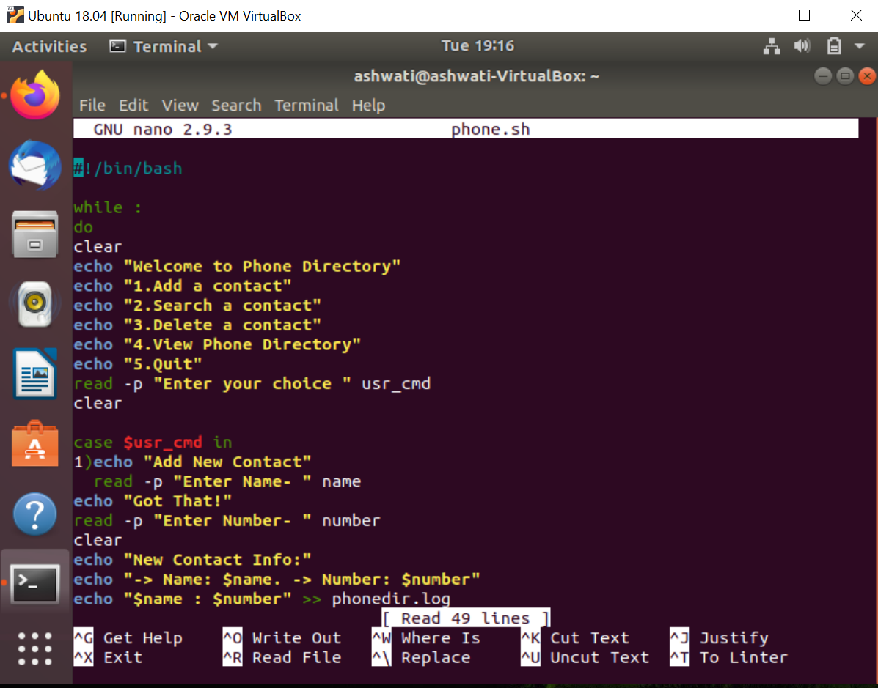

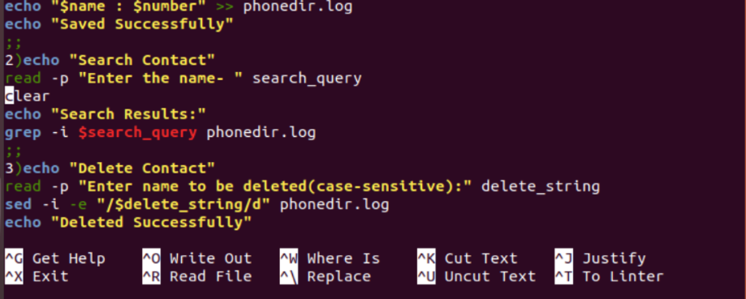

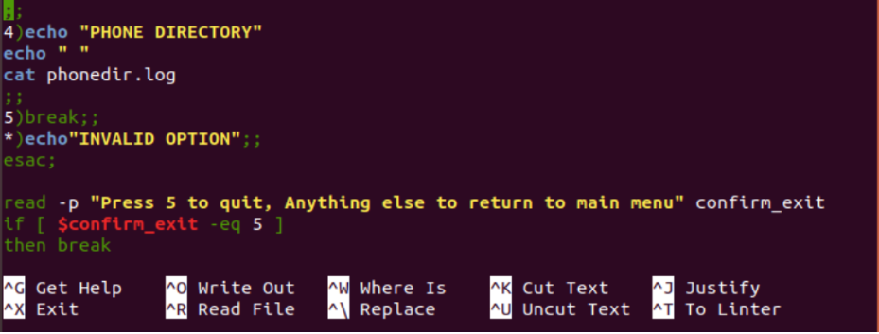

**RESULT**-

OUTPUT-

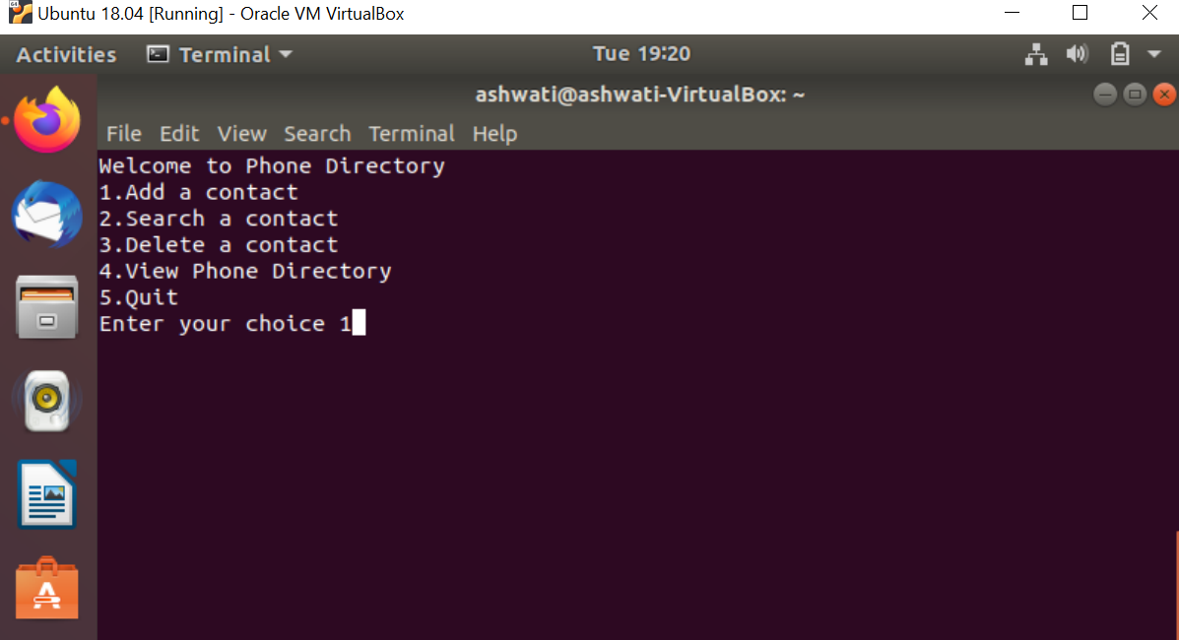

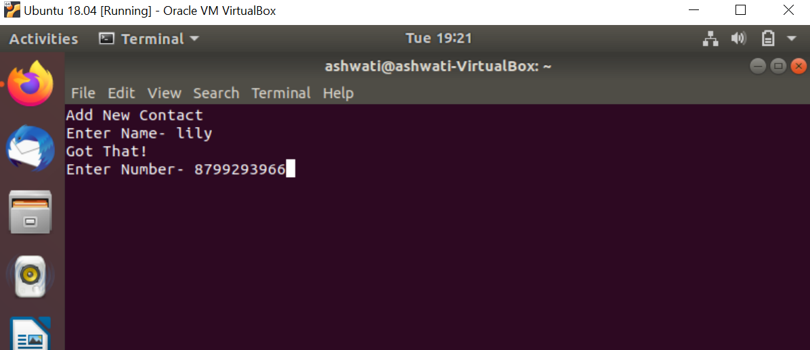

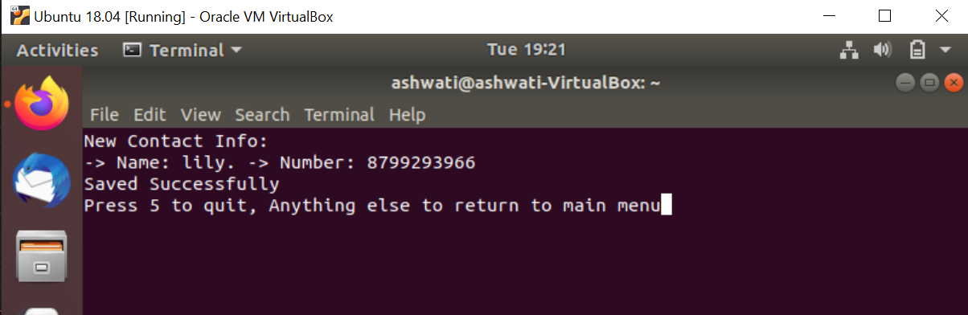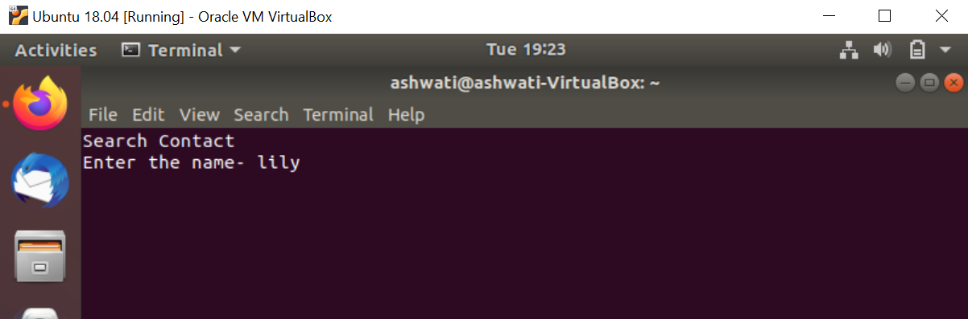

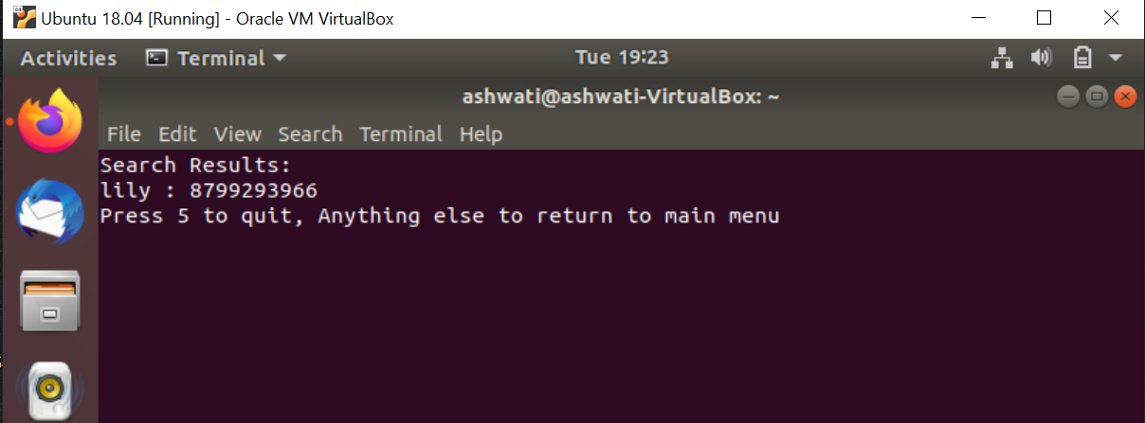

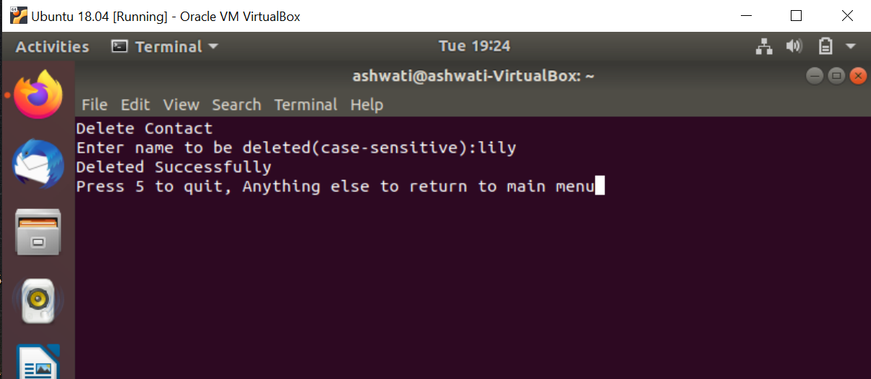

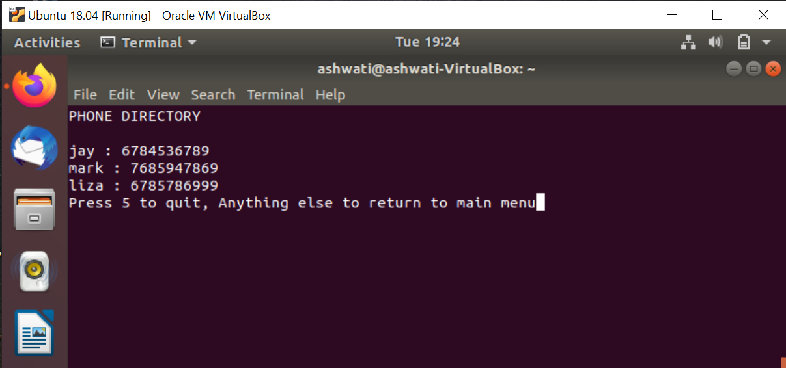

**CONCLUSION**

**Uses of phone directory-**

A phone directory is a listing of telephone subscribers in a geographical area or subscribers to services provided by the organization that publishes the directory. Its purpose is to allow the telephone number of a subscriber identified by name to be found.

**Future Scope-**

It is not possible to develop a system that makes all the requirements of the user. User requirements keep changing as the system is being used. Some of the future enhancements that can be done to this system are-

* As the technology emerges, it is possible to upgrade the system.
* Based on future security issues, security can be improved using emerging technologies.

**Conclusion-**

This project has been computed successfully and was also tested successfully by taking “test cases”. It is user friendly and has required options which can be utilized by the user to perform the desired operations.

The goals achieved are-

* Optimum utilization of resources.
* Efficient management of records.
* Simplification of the operations.
* Less processing time and getting required information.
* User friendly.
* Portable and flexible for further enhancement.

**REFERENCES-**

<https://linuxconfig.org/bash-scripting-tutorial-for-beginners>

<https://www.tutorialkart.com/bash-shell-scripting/bash-tutorial/>

<https://en.wikipedia.org/wiki/Telephone_directory>